How to Use JFinder

- Double click the program executable, JFinder.exe, the window will show up as the following:

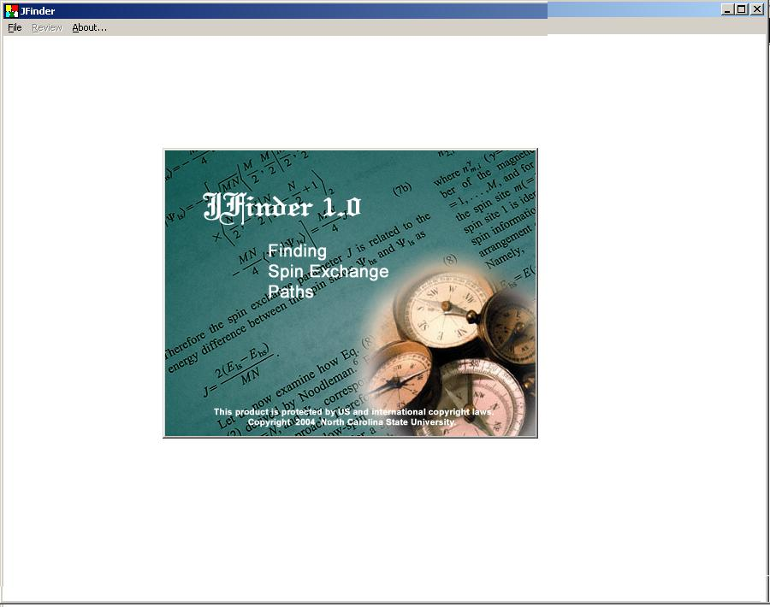

- Click File ->Create Structure, MASC program will run. If you already have structure file (either, .CI files or .MCI files), use File->Open to open the structure. If there is no such file, use File->New to create one (Use all functions of MASC).

MASC will show structures in the extended ranges (a: -0.3 – 1.3, b: -0.3 – 1.3, c: -0.3 to 1.3). If you need more atoms, use Edit->Define Crystal to change the range.

For avoiding missing possible pairs, it is important to extend the unit cell. For a system with a high symmetry and a few unsymmetrical atoms, large range may be needed.
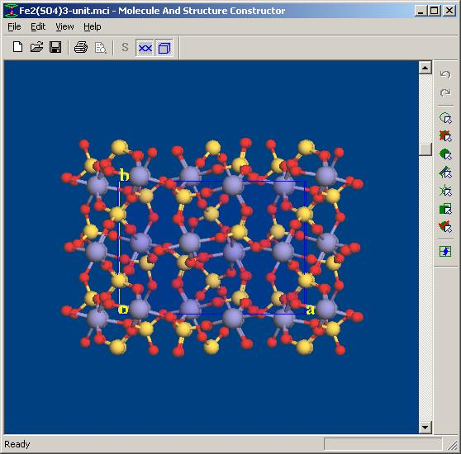

After having desired extended structure, exit MASC. You may save the extended structure, or exit without saving it.

- After MASC processed a structure, the following text is shown on the screen:

“Select menu File -> Find Interactions to calculate…”

It will open a dialog box to determine metal and ligans atoms, and other parameters:

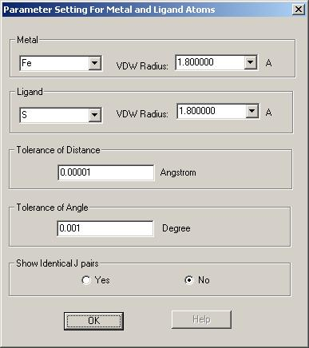
You should select correct atoms (for example, select Fe and O), and use or modify corresponding van der Waals radii. The tolerances of lengths and angles are used for comparing local structure of pairs to remove duplicate pairs. The program will find all spin exchange pairs, which are unique from the viewpoint of crystal structure. That is, any two pairs cannot be overlapped by translation operations. However, among these pairs some may be considered as identical, if their local environment is exactly the same. That is, all atom distances, angles and dihedral angles of two pairs (metal-ligand-metal or metal-ligand-ligand-metal chains) are identical.

There are two choices for finding pairs. If selecting “Show Identical J Pairs”, a dialog box will show all pairs even though some of them have the identical environments. If selecting “No”, only a few pairs will be listed:

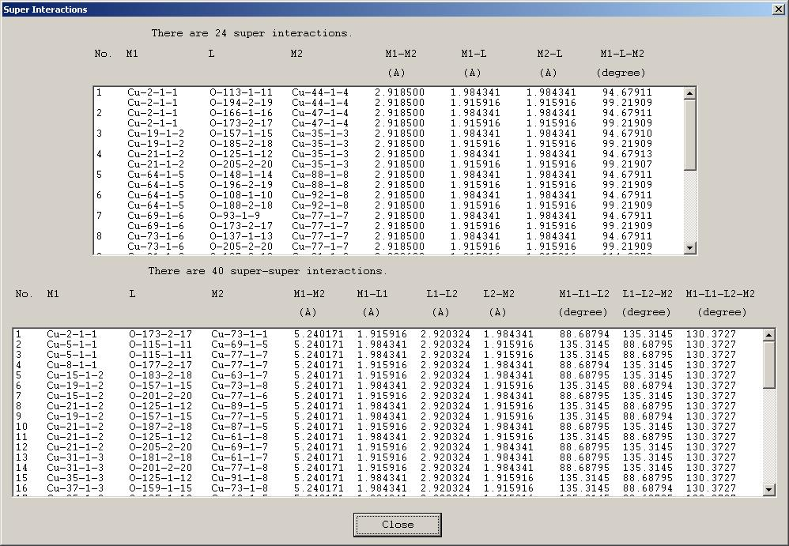

(4) For each line it is possible to show the pair with MASC program. The user can clearly examine the pair, which is highlighted in the structure image.

(5) When listing pairs in this dialog box, the program also saves the result in the directory where the input file locates. The output file uses the same name as the structure file and “.jfo” as extension. For instance, if the structure file is CUO.MCI in C:\primeC\jFinder, the output file is C:\primeC\jFinder \CUO.JFO.

September 3, 2004

